DECISIONS DELEGATED TO OFFICERS

Decision title: | Award of contract to Witney Cable for low voltage works at Energy Superhub Oxford
Decision date: | 06/04/22
Source of delegation: | This decision was delegated to officers under Part 4.4 of the Council’s Constitution: all executive functions except those in Part 4.5, 4.6 and 4.7 are delegated to the officers in the senior management structure.
What decision was made? | To award a contract to Witney Cables for the completion of low voltage works and connecting transformer to a low voltage switchboard as part of the Energy Superhub Oxford project. The value of the contract is £25,000.
Purpose: | To enable the completion of low voltage works, including connecting transformer to a low voltage switchboard as part of the Energy Superhub Oxford project.
Reasons: | Witney Cables demonstrated best value for money against a tender for low voltage works.
Decision made by: | Mish Tullar, Head of Corporate Strategy
Other options considered: | The option to choose not to deliver the programme was available, but was effectively ruled out after the Cabinet decided to deliver the programme.
Documents considered: | None
Key or Not Key: | Not key
Wards significantly affected: | None
Declared conflict of interest: | None
This form was completed by:  Name & title:  Date: | Kristina Mould  Capital Programme Project Manager  06/04/22

Approval checklist

Approver | Name and job title | Date
Decision maker | Mish Tullar, Head of Corporate Strategy  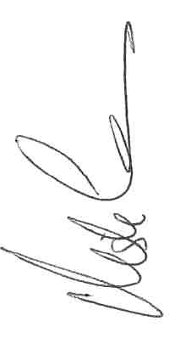 | 06/04/2022

